**How to Get First and Last Day of a Month in SQL Server**

To get the **first day of the previous month** in SQL Server, use the following code:

SELECT DATEADD(mm, DATEDIFF(mm, 0, GETDATE()) - 1, 0)

**[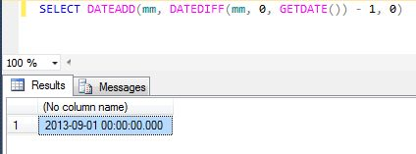](http://zarez.net/wp-content/uploads/2013/10/first_day_of_last_month.jpg)**

To get the **last day of the previous month**:

SELECT DATEADD(DAY, -(DAY(GETDATE())), GETDATE())

**[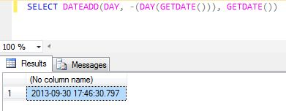](http://zarez.net/wp-content/uploads/2013/10/last_day_of_last_month.jpg)**

To get the **first day of the current month**:

SELECT DATEADD(mm, DATEDIFF(mm, 0, GETDATE()), 0)

**[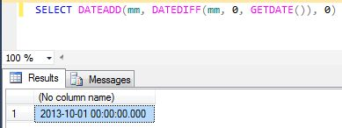](http://zarez.net/wp-content/uploads/2013/10/first_day_of_current_month.jpg)**

To get the **last day of the current month**:

SELECT DATEADD (dd, -1, DATEADD(mm, DATEDIFF(mm, 0, GETDATE()) + 1, 0))

**[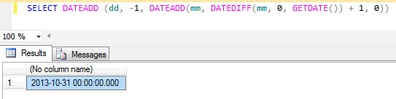](http://zarez.net/wp-content/uploads/2013/10/last_day_of_current_month.jpg)**

To get the **first day of the next month**:

SELECT DATEADD(mm, DATEDIFF(mm, 0, GETDATE()) + 1, 0)

**[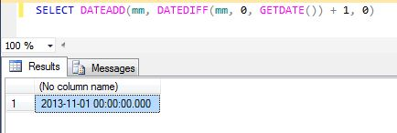](http://zarez.net/wp-content/uploads/2013/10/first_day_of_next_month.jpg)**

To get the **last day of the next month**:

SELECT DATEADD (dd, -1, DATEADD(mm, DATEDIFF(mm, 0, GETDATE()) + 2, 0))

**[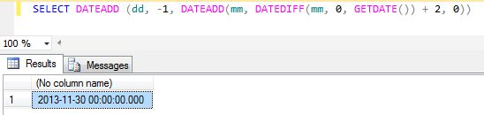](http://zarez.net/wp-content/uploads/2013/10/last_day_of_next_month.jpg)**